Project plan Action Developer
Don’t know where to get started? Check out this step by step changemaker video!

Hi Changemaker!
Great that you want to make a change for children’s rights. This is your changemaking project plan. Let’s find out what you want to do and how you are going to do it!
General information
My name is:
I am a girl/boy:
My date of birth is:
My address is:
I speak the following languages:

Background
Tell us a little bit about yourself: Who are you? Do you go to school? Do you have siblings, What are your hobbies? etc.

Have you done changemaking activities before? If yes, what did you do and what are you still doing?

Do you work with organizations or persons in your community? If yes, which?

Dream
What is your dream for the future? What kind of change do you wish to see?

“If you want change, you should work on it”
Chaeli Mycroft (Winner International Children’s Peace Prize 2011)
Problem statement
What is the problem in your community that you want to help solve with your project?
Do you want to know what kind of changemaker you are?
Find out by taking the quiz on the platform!
Take the quiz here.
When do you know enough about a problem or theme?
You know enough when you can explain the problem clearly to other people and they understand it, so you can get your message across.

Project focus

My project focuses on the following children’s right(s): (Choose max. 3 rights)

- Education
- Gender Equality
- Poverty
- Child participation
- Child marriage

- Violence
- Street children
- Child abuse
- Child labor
- Child trafficking

- Health
- Discrimination
- Name & Nationality
- Refugee children
- Hiv/aids

- Peace
- Disabilities
- Bullying
- Environment
- Sexual reproduction health
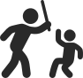

Let’s make a plan
Now it’s time to get started and make a project plan! When you make a plan, it is important to be as precise as possible.

Please check the KidsRights project guidelines to see what kind of projects KidsRights supports in the Changemakers Program.

Title of your project:

Summary of your project (maximum 100 words):

How long will your project take?
For this program please limit your project to around 2 to 3 months and/or 1 to 2 activities.
If you already have an ongoing project, that’s great! Just list the 1 or 2 activities you will be doing in the upcoming months.
Duration of Project
Start date
Finishing date

Which activities are you going to do within your project? Please be as specific as possible. For example: What will you be doing during this activity, how many people do you want to join your activities? Who are they? How old are they? How long will activity take?
Activity | Who will participate? | Goal of activity | Where & When
Sort of activity:
Describe what you will do:

Sort of activity:

Describe what you will do:

Sort of activity:

Describe what you will do:

How will these activities help solve the problem?

Who will help you carry out your project? (Other young changemakers, adults or organizations) Please be as specific as possible. For example: How many people are helping you, who are they, how old are they? How do you know them?

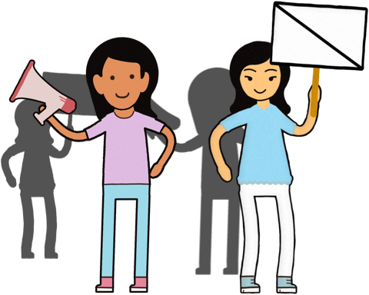
What will your role and tasks be in the project?

Challenges
What do you think will be the most difficult part of your project?

Results
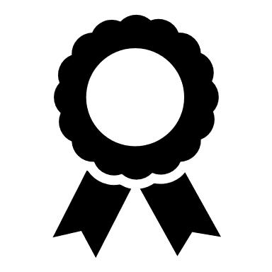
When is this project a success? When have you achieved your goal?

How will you measure if you have achieved this?

“Do all you can. With what you have, in the time you have,
in the place you are”
Nkosi Johnson (Winner International Children’s Peace Prize 2005)
Key message to the world
What is your key message to other changemakers? (Maximum 25 words)

Social Media
Do you have a social media account for your project or organization? If so, can you please share the account? We would love to follow you and put it on your profile on our website!

Support from KidsRights
All right! You now have a project plan to make a change! We hope that by filling out this form we already made you think about the different steps to take in your project.

We will give you feedback on your project plan, share advice and tips & tricks on certain challenges.

Other than the support mentioned above: what kind of support would you like to get from KidsRights?

Finished – What now?
Please upload this project plan on your own account via: https://www.thekidsrightschangemakers.org

We will read your project plan and contact you to see how we can support your project.
Let’s make a change!

Contact
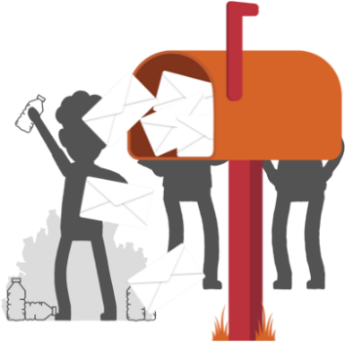
Do you have any questions while filling out this template or do you have questions about the Changemaking Program? Feel free to contact us:

Email to : changemaker@kidsrights.org
Whatsapp: +31 6 83321251

